**Data Modeling and Data Analysis Using Microsoft SQL**

* **Explanation**
* a star schema data model used in a data warehouse or business intelligence system. It consists of one Fact table (FactSales) and several Dimension tables (DimCustomer, DimProduct, DimDate, DimRegion).

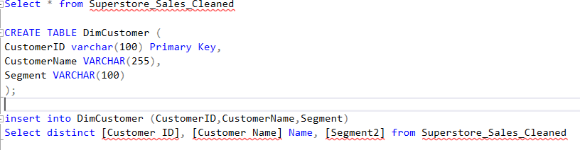

* **Purpose**
* To create a clean **customer dimension table (DimCustomer)** by extracting unique customer records from the main sales fact table (Superstore_Sales_Cleaned). This is useful for building dashboards or star schema models in data analysis and business intelligence.

* **Purpose**

The purpose is to create a **DimRegion** table with unique regional data by using ROW_NUMBER to remove duplicates.

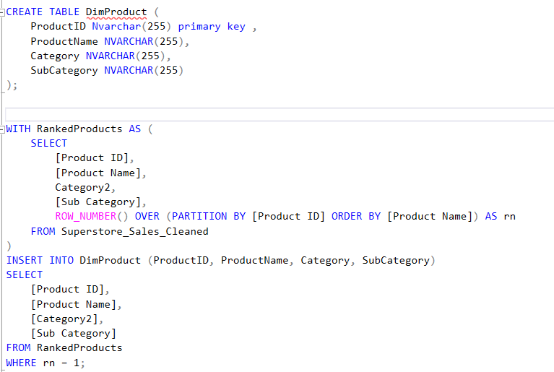

* **Purpose**
* code creates a DimProduct table with ProductID (primary key), ProductName, Category, and SubCategory. It ranks products from Superstore_Sales_Cleaned using ROW_NUMBER() and inserts the top-ranked row into DimProduct for data warehousing.

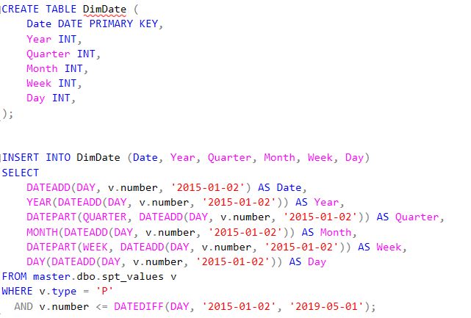

* **Purpose**
* To generate a date dimension table (DimDate) that contains detailed breakdowns of each date between January 2, 2015 and May 1, 2019.

* **Purpose**
* Sets up a fact table for sales transactions with referential integrity to dimension tables, likely for a data warehouse.

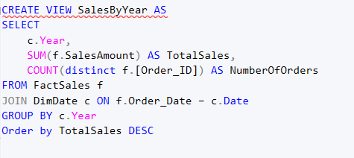

* **Purpose**
* Creates a view named SalesByYear to summarize sales data by year.

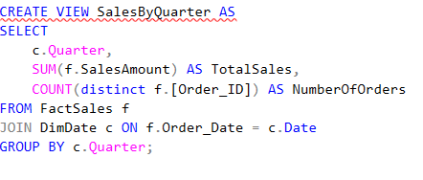

* **Purpose**
* Creates a view named SalesByQuarter to summarize sales data by quarter. Its purpose:

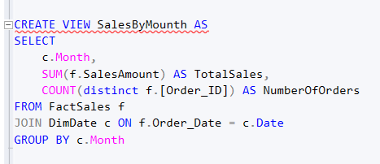

* **Purpose**
* creates a view named SalesByMonth to summarize sales data by month

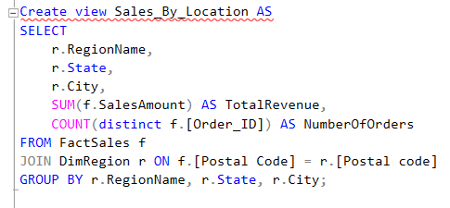

* **Purpose**
* creates a view named Sales_By_Location to summarize sales data by location.

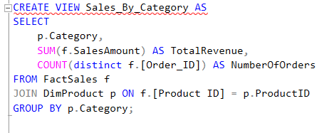

* **Purpose**
* creates a view named Sales_By_Category to summarize sales data by product category.

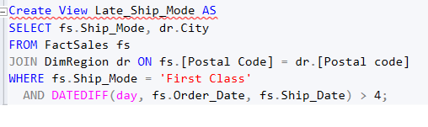

* **Purpose**
* creates a view named Late_Ship_Mode to identify late shipments.